1207878: Prasad Kaulage

1. check git version > git –version

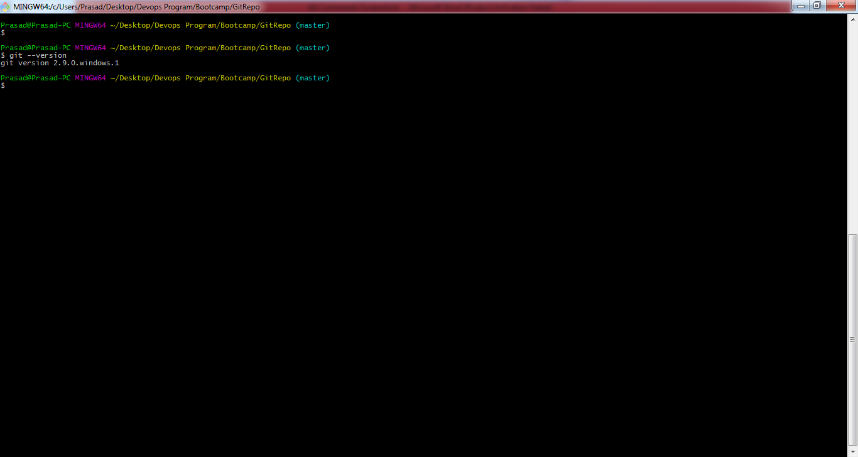

1. configure username > git config --global user.name = "your name"

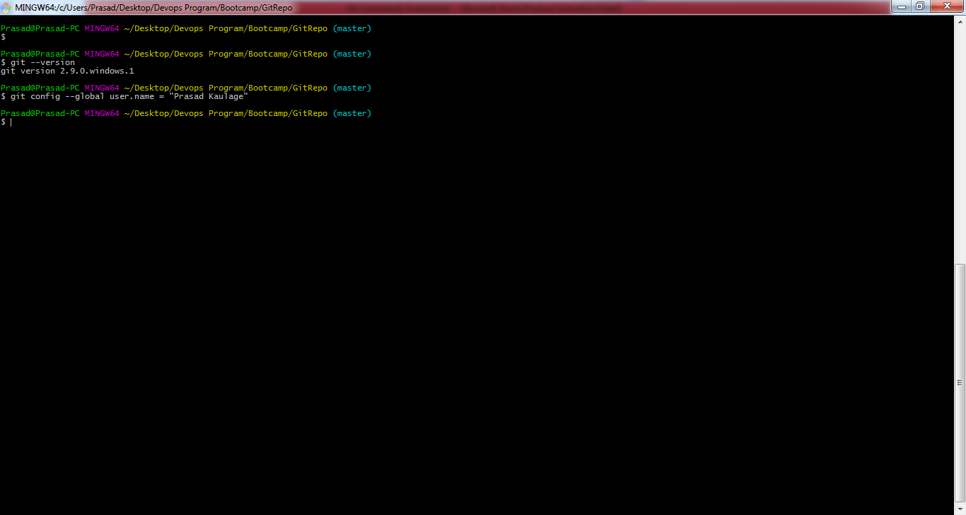

1. configure email > git config --global user.email = "your email"

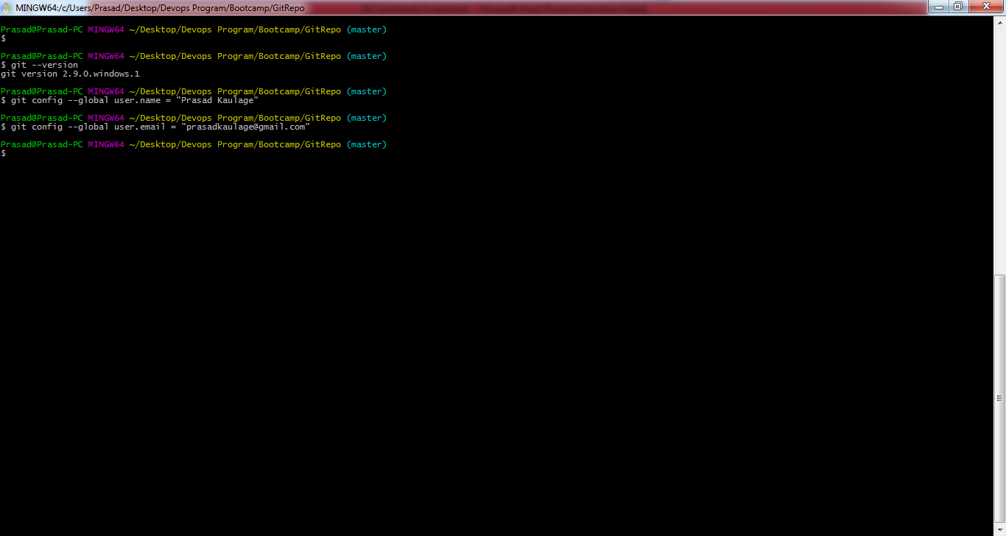

1. > To create a directory

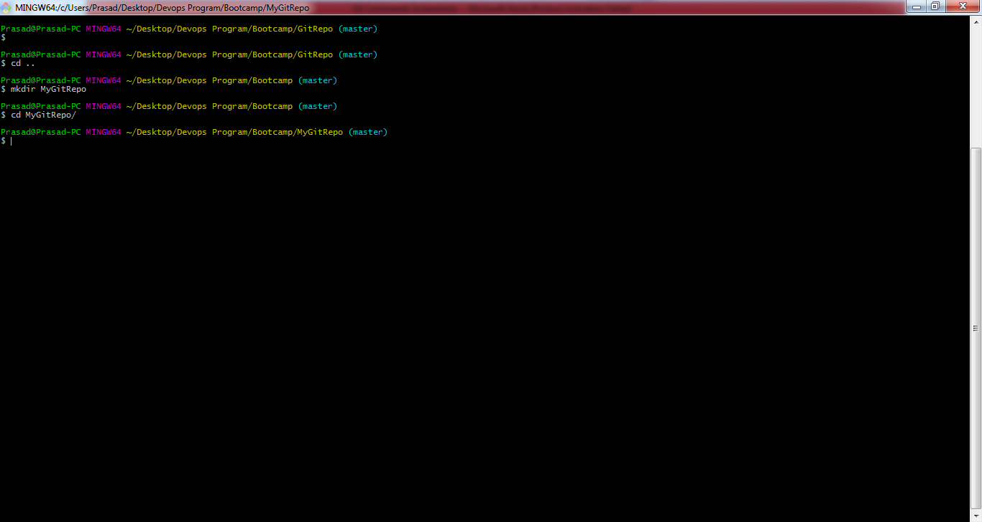

1. git init - converts a directory into a git repository

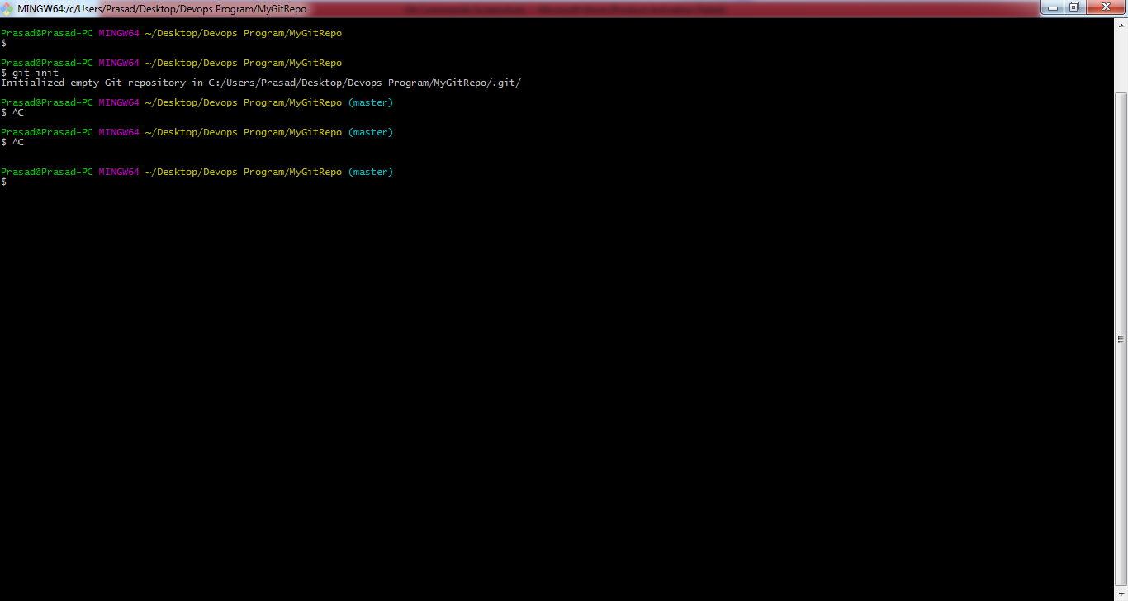

1. > To add a single or muiltiple files to staging area

git add fileName or git add .



1. > To commit the changes in the local repository.

git commit -m "commit message"

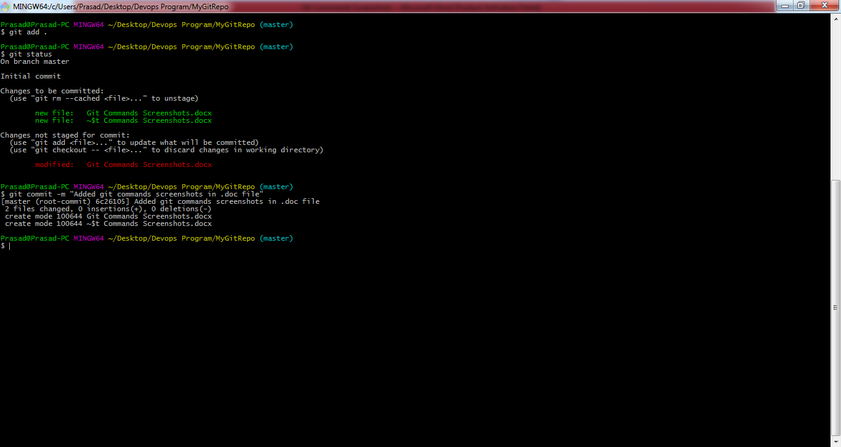

1. > To list the status of the files in staging area.

git status

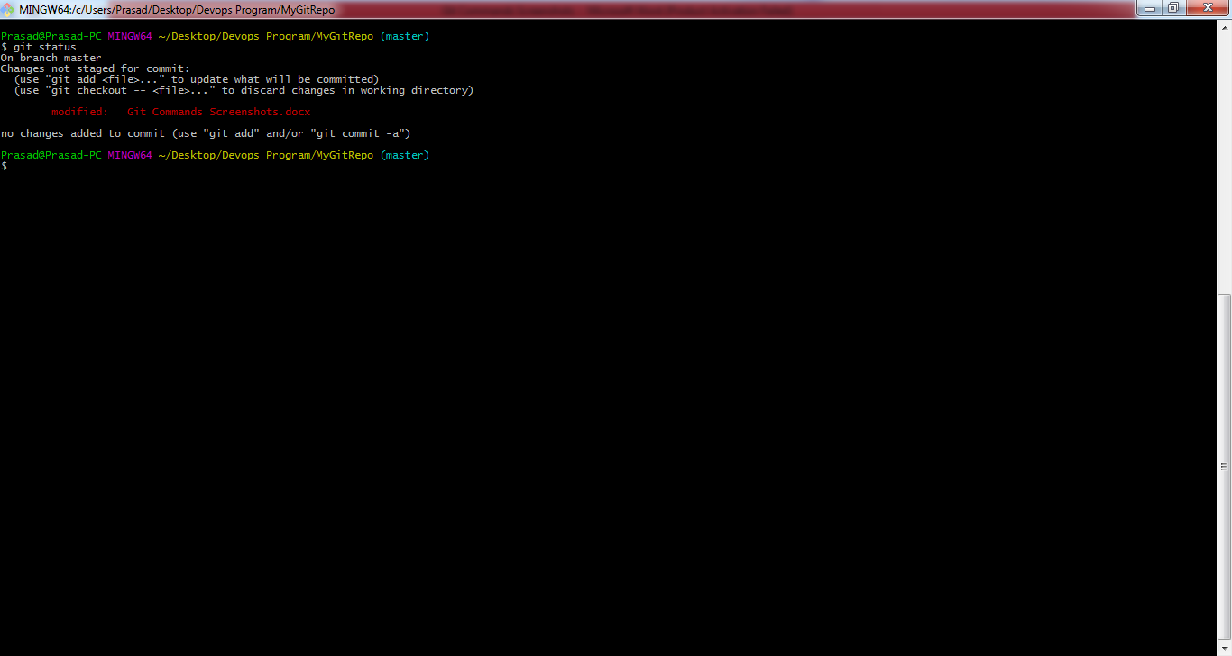

1. > To connect a local repository to a specific remote repository.

git remote add origin <ssh url>

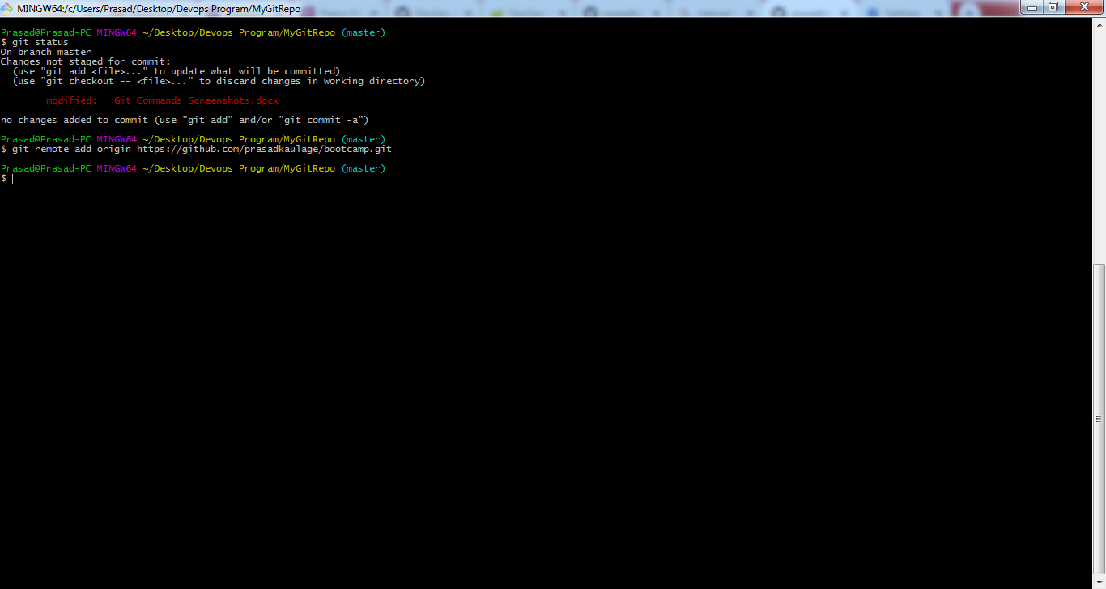

1. > To Push the changes to master branch of the remote git repository.

git push origin master

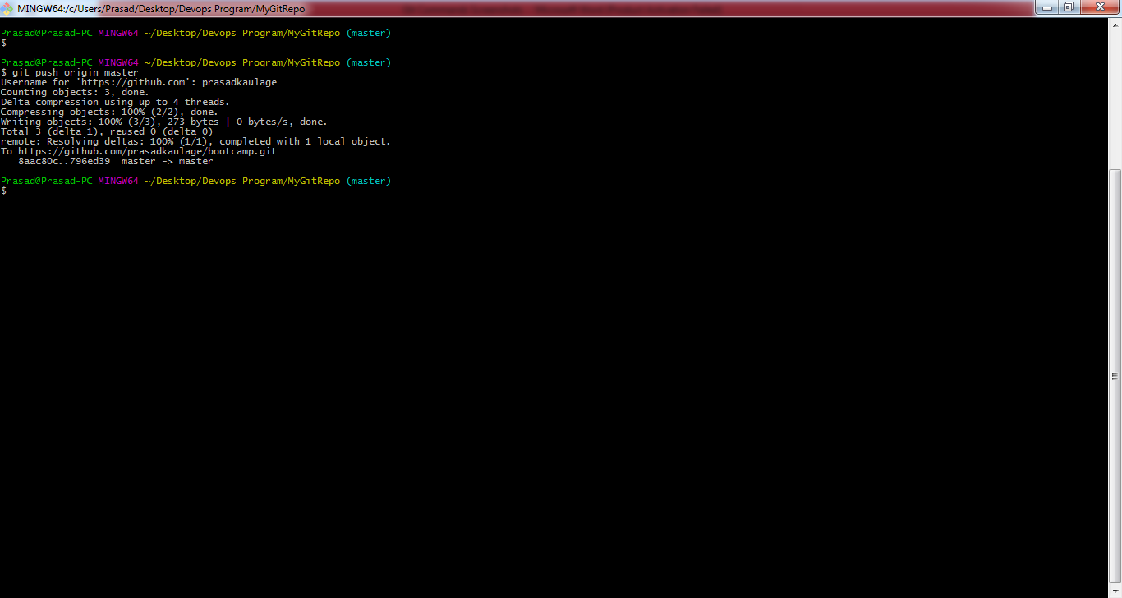

1. > To Pull the changes from master branch of the remote git repository.

git pull origin master

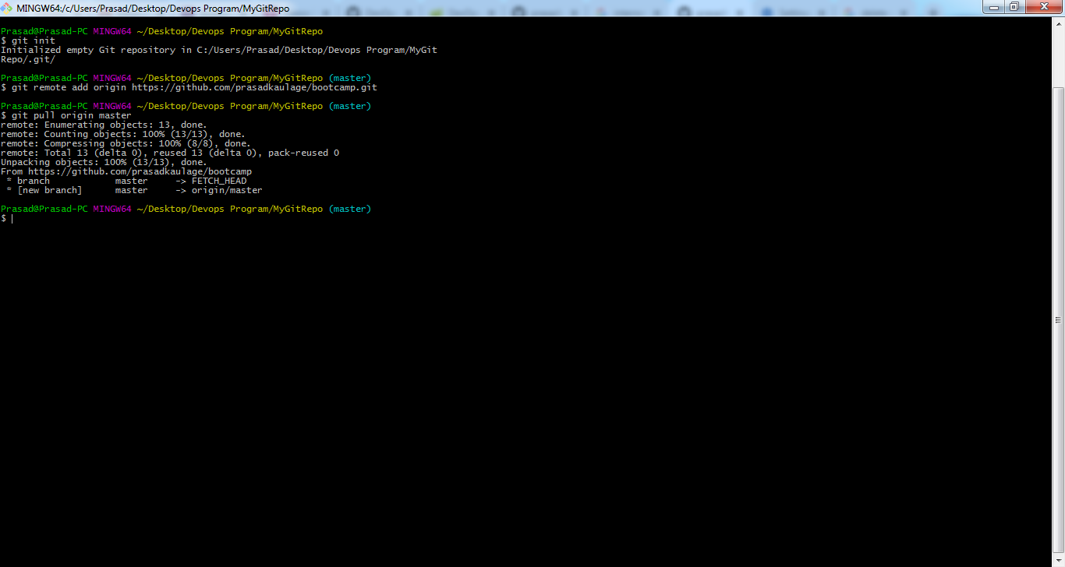

1. > To List all the branches

git branch

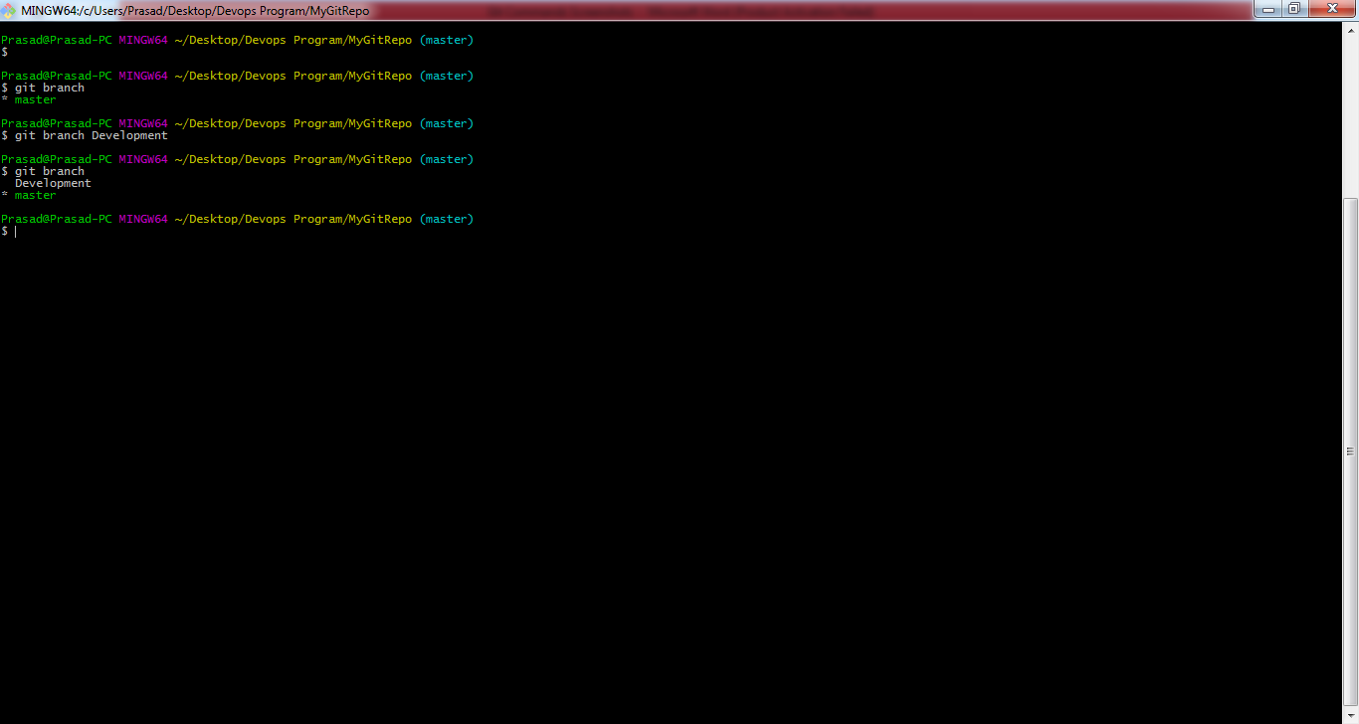

1. > To create a new branch

git branch $branchName

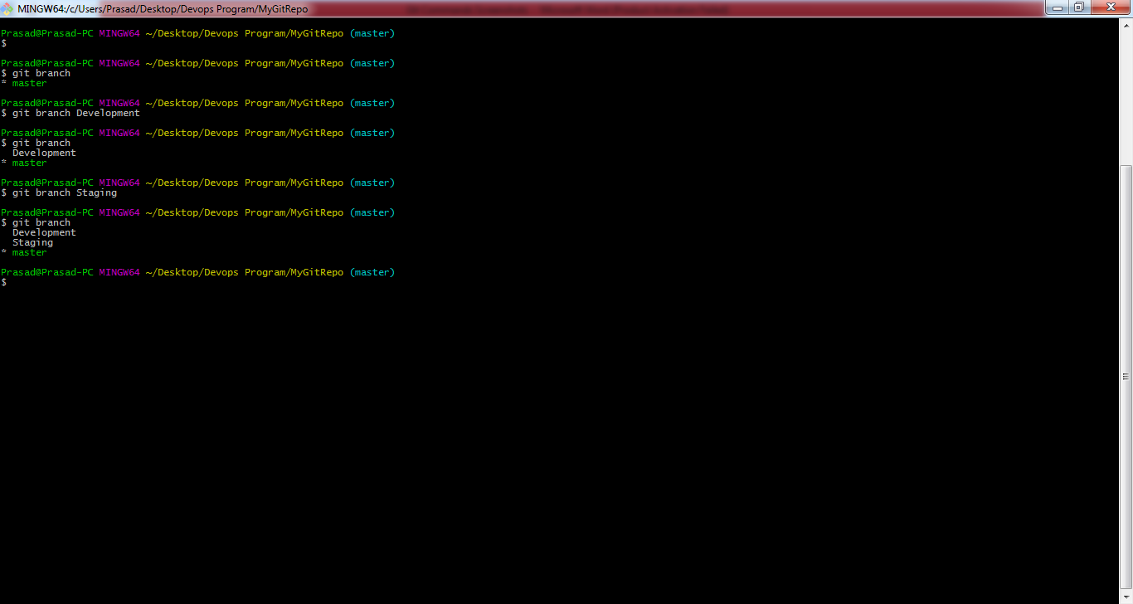

1. > To delete an existing branch

git branch -d $branchName

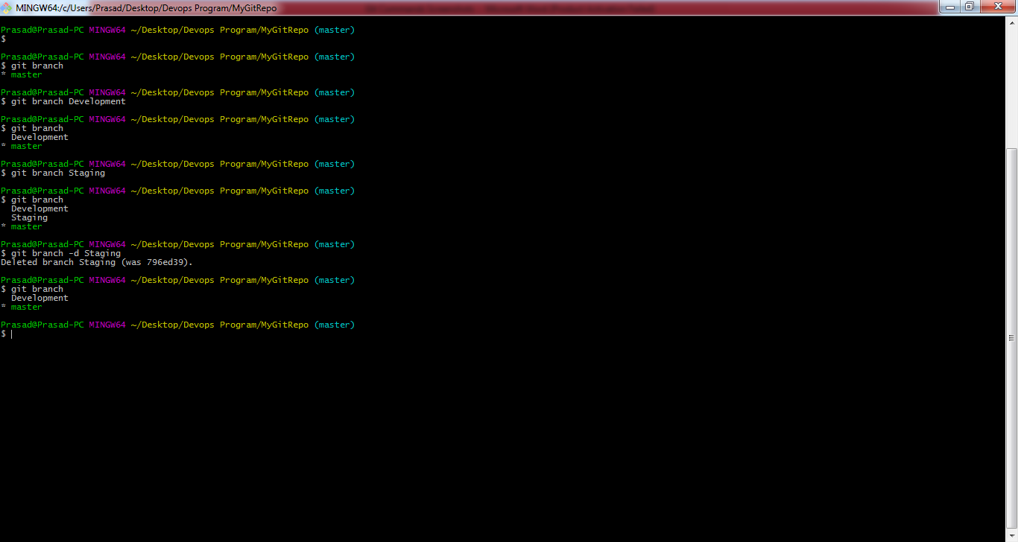

1. > To merge a child branch to master

git merge $branchName

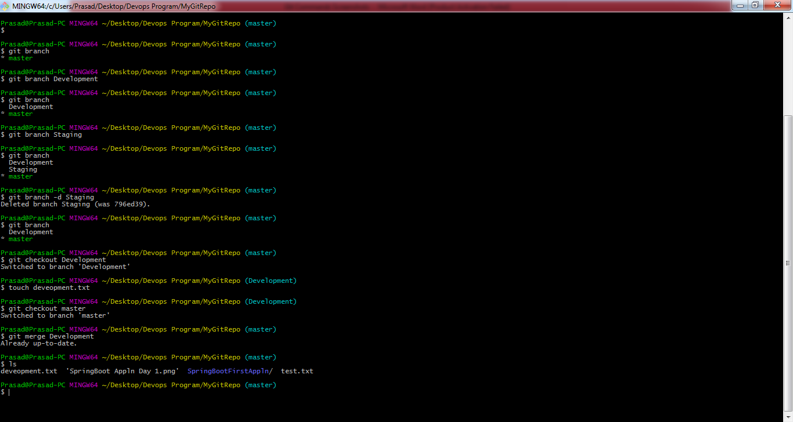

1. > To save the changes, when they are not in state of commit.

git stash

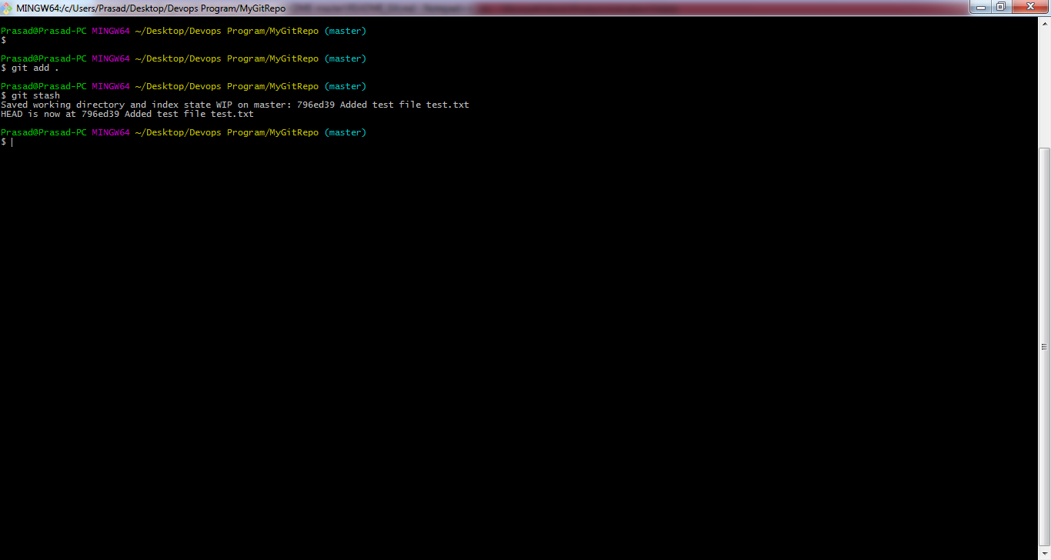

1. > To stash changes and clearing up the directory

git stash –u

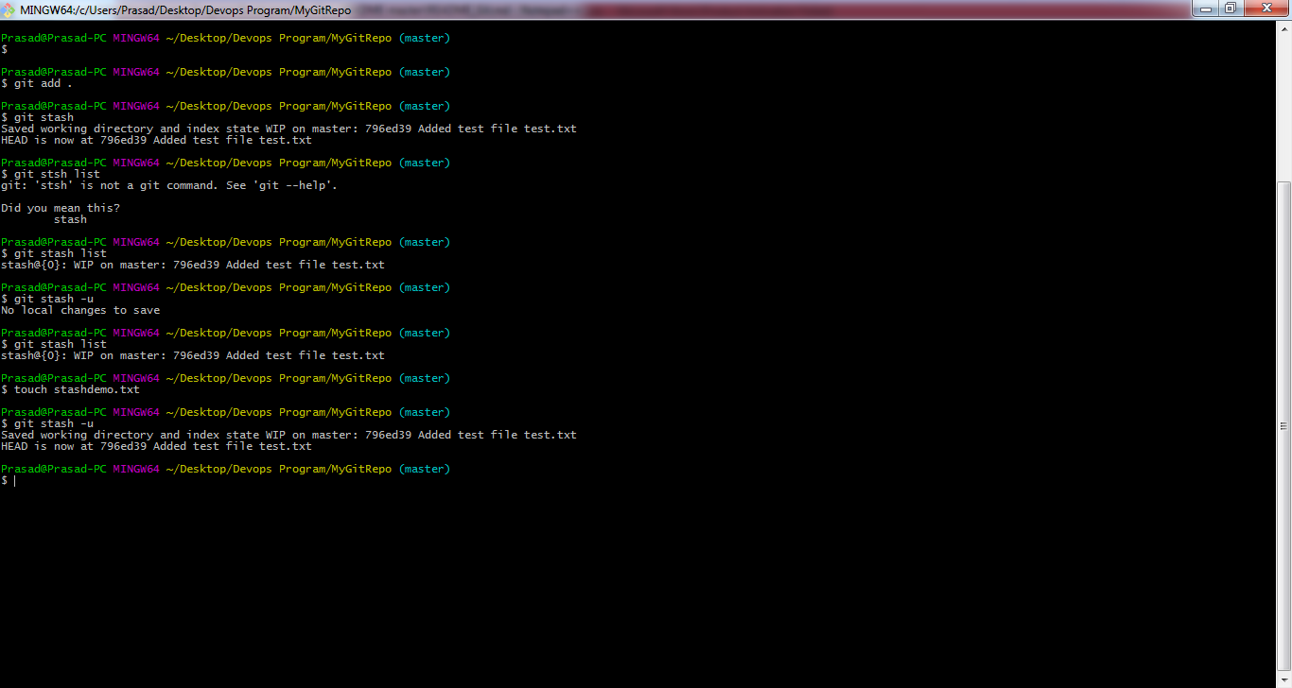

1. > To List the stashes created.

git stash list

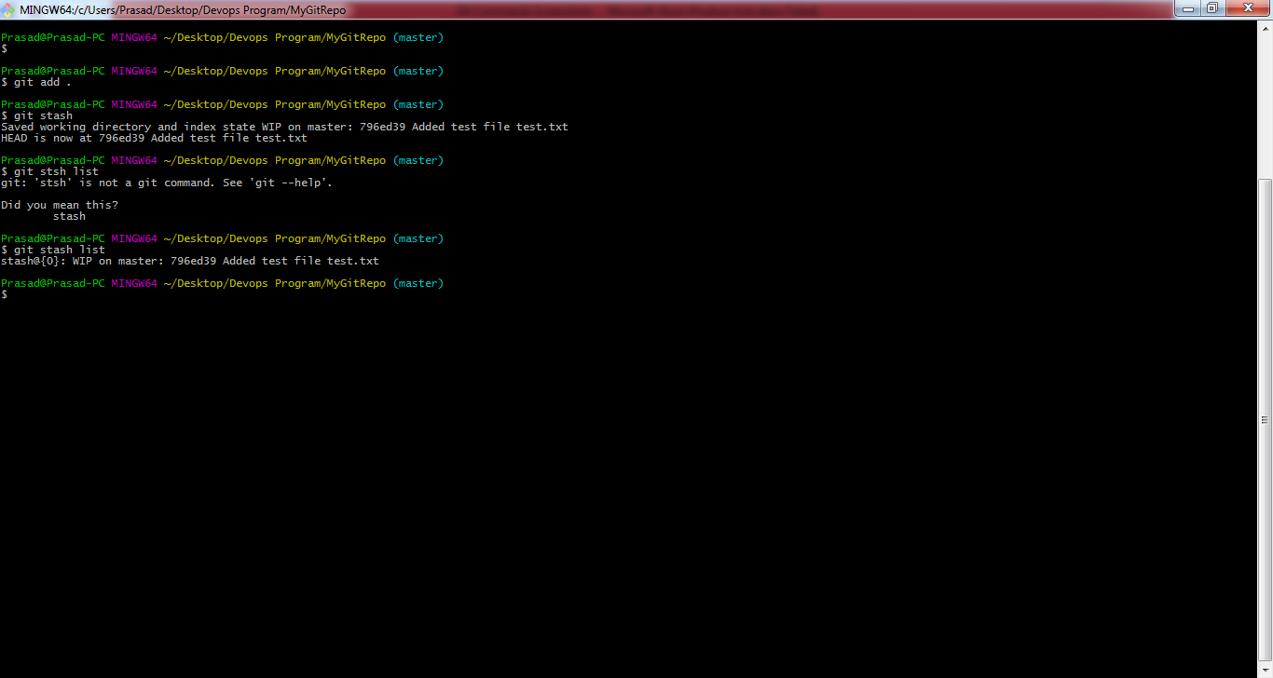

1. > To get the context and history of logs of a repository

git log

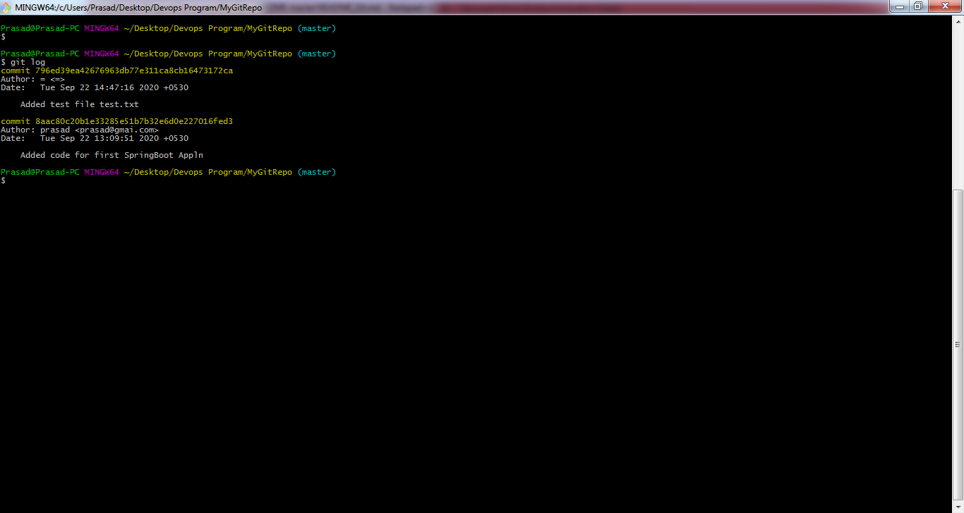

1. > To Copy and Store a set of commit outside of our repository.

git rebase

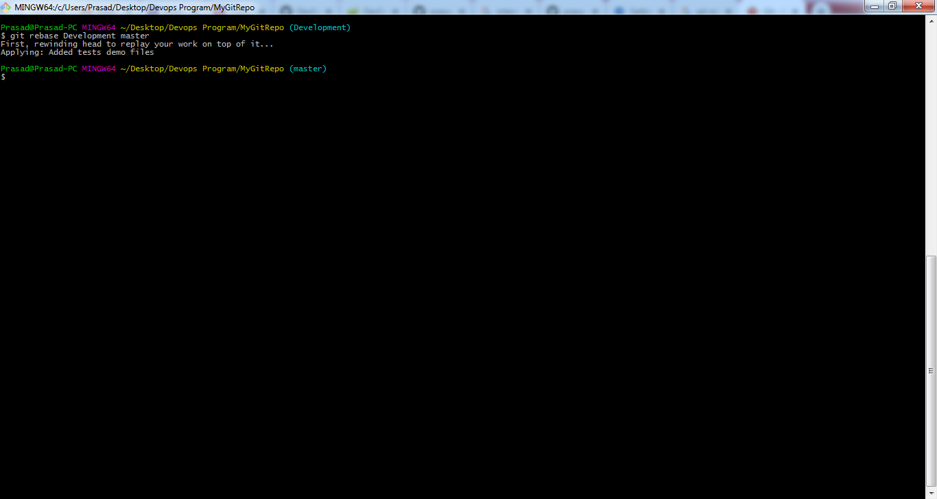

1. > To revert back to the previous version of the file.

git revert

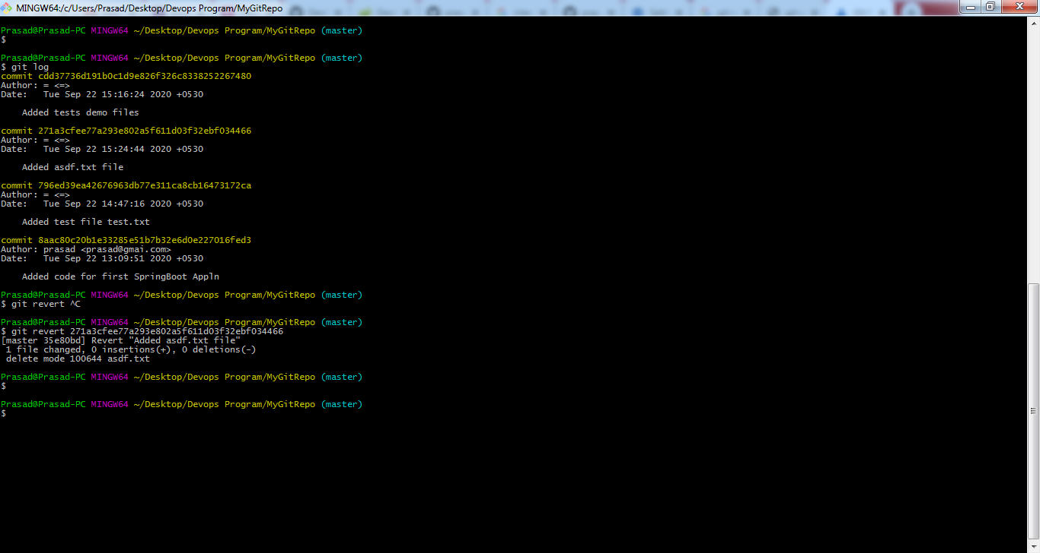

1. > To Clone a remote git repository into a local git repository.

git clone <repo name>

